# Exercises: Advanced Querying

This document defines the **exercise assignments** for the ["Databases Advanced – EF Core" course @ Software University](https://softuni.bg/trainings/1741/databases-advanced-entity-framework-october-2017).

# BookShop System

For the following tasks, use the [BookShop](http://svn.softuni.org/admin/svn/csharp-databases/2017-Sept/DB-Advanced-EF-Core/06.%20DB-Advanced-EF-Core-Advanced-Querying/BookShop.zip) database. You can download the complete project or create it yourself in **task 0**,but you should still use the pre-defined Seed() method from the project to have the same **sample** data.

## Book Shop Database

You must create a **database** for a **book** **shop** **system**. It should look like this:

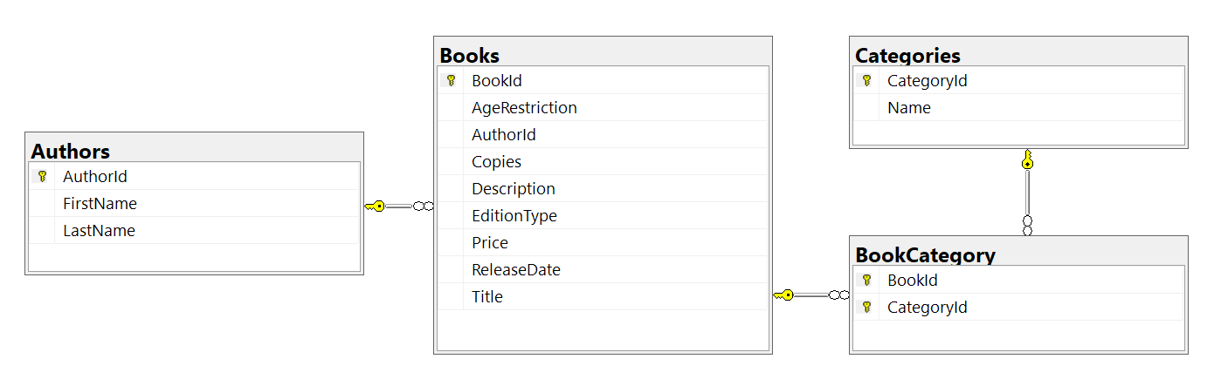

### Constraints

Your **namespaces** should be:

* BookShop.StartUp – for your **StartUp** class
* BookShop.Data – for your DbContext
* BookShop.Models – for your models

Your **models** should be:

* BookShopContext – your DbContext
* Author:
  + AuthorId
  + FirstName (up to 50 characters, unicode, not required)
  + LastName (up to 50 characters, unicode)
* Book:
  + BookId
  + Title (up to 50 characters, unicode)
  + Description (up to 1000 characters, unicode)
  + ReleaseDate (not required)
  + Copies (an integer)
  + Price
  + EditionType – enum (Normal, Promo, Gold)
  + AgeRestriction – enum (Minor, Teen, Adult)
  + Author
  + BookCategories
* Category:
  + CategoryId
  + Name (up to 50 characters, unicode)
  + CategoryBooks
* BookCategory – mapping class

For the following tasks, you will be creating methods that accept a BookShopContext as a parameter and use it to run some queries. Create those methods inside your **StartUp** class and upload your whole solution to **Judge**.

## Age Restriction

Create a **method GetBooksByAgeRestriction**(BookShopContext context, **string** **command**), that returns in a **single** **string** allbook **titles**, each on a **new line,** that have **age** **restriction**, equal to the **given** **command**. Order the titles **alphabetically**.

Read **input** from the console in your **main** **method**, and call your **method** with the **necessary** **arguments**. Print the **returned** **string** to the console. **Ignore** casing of the input.

### Example

|  |  |
| --- | --- |
| **Input** | **Output** |
| miNor | A Confederacy of Dunces  A Farewell to Arms  A Handful of Dust  … |
| teEN | A Passage to India  A Scanner Darkly  A Swiftly Tilting Planet  … |

## Golden Books

Just like in task 1, write a method **GetGoldenBooks**(BookShopContext context), that returns in a **single** string **titles of the golden edition books** that have **less than 5000 copies**,each on a **new line**. Order them by **book** **id** ascending.

Call the **GetGoldenBooks()** method in your **Main()** and print the returned string to the console.

### Example

|  |
| --- |
| **Output** |
| Nine Coaches Waiting  Of Human Bondage  The Other Side of Silence  … |

## Books by Price

Write a **GetBooksByPrice**(BookShopContext context) method that returns in a single string all **titles and prices** **of books** with **price higher than 40**, each on a **new** **row** in the **format** given below. Order them by **price** descending.

### Example

|  |
| --- |
| **Output** |
| O Pioneers! - $49.90  That Hideous Strength - $48.63  A Handful of Dust - $48.63  … |

## Not Released In

Write a **GetBooksNotRealeasedIn**(BookShopContext context**, int year**) method that returns in a **single** string all **titles of books** that are **NOT released** on a given year. Order them by **book** **id** ascending.

### Example

|  |  |
| --- | --- |
| **Input** | **Output** |
| 2000 | Absalom  Nectar in a Sieve  Nine Coaches Waiting  … |
| 1998 | The Needle's Eye  No Country for Old Men  No Highway  … |

## Book Titles by Category

Write a **GetBooksByCategory**(BookShopContext context, string input) method that **selects** and **returns** in a single string the **titles of books** by a given **list of categories**. The list of **categories** will be given in a single line separated with one or more spaces. Ignore casing. Order by **title** alphabetically.

### Example

|  |  |
| --- | --- |
| **Input** | **Output** |
| horror mystery drama | A Fanatic Heart  A Farewell to Arms  A Glass of Blessings  … |

## Released Before Date

Write a **GetBooksReleasedBefore**(BookShopContext context, string date) method that **returns the title, edition type and price** of all books that are **released before a given date**. The date will be a string **in format** **dd-MM-yyyy**.

Return all of the rows in a **single** string, ordered by **release** **date** **descending**.

### Example

|  |  |
| --- | --- |
| **Input** | **Output** |
| 12-04-1992 | The Sun Also Rises - Normal - $20.40  Thrones - Promo - $21.41  Mr Standfast - Gold - $29.99  … |
| 30-12-1989 | A Fanatic Heart - Normal - $9.41  The Curious Incident of the Dog in the Night-Time - Normal - $23.41  The Other Side of Silence - Gold - $46.26  … |

## Author Search

Write a **GetAuthorNamesEndingIn**(BookShopContext context, string input) method that returns the **full** **names** of **authors**, whose **first** **name** ends with a **given** **string**.

Return all **names** in a **single** **string**, each on a **new** **row**, ordered alphabetically.

### Example

|  |  |
| --- | --- |
| **Input** | **Output** |
| e | George Powell  Jane Ortiz |
| dy | Randy Morales |

## Book Search

Write a **GetBookTitlesContaining**(BookShopContext context, string input) method that returns the **titles** of **book**, which contain a **given** **string**. Ignore casing.

Return all **titles** in a **single** **string**, each on a **new** **row**, ordered alphabetically.

### Example

|  |  |
| --- | --- |
| **Input** | **Output** |
| sK | A Catskill Eagle  The Daffodil Sky  The Skull Beneath the Skin |
| WOR | Great Work of Time  Terrible Swift Sword |

## Book Search by Author

Write a **GetBooksByAuthor**(BookShopContext context, string input) method that **returns all titles of books and their authors’ names** for books, which are written by authors whose last names **start with the given string**.

Return a single string with each title on a new row. **Ignore** casing. Order by **book** **id** ascending.

### Example

|  |  |
| --- | --- |
| **Input** | **Output** |
| R | The Heart Is Deceitful Above All Things (Bozhidara Rysinova)  His Dark Materials (Bozhidara Rysinova)  The Heart Is a Lonely Hunter (Bozhidara Rysinova)  … |
| po | Postern of Fate (Stanko Popov)  Precious Bane (Stanko Popov)  The Proper Study (Stanko Popov)  … |

## Count Books

Write a **CountBooks**(BookShopContext context, int lengthCheck) method that **returns the number of books,** which have a **title longer than the number** given as an input.

### Example

|  |  |  |
| --- | --- | --- |
| **Input** | **Output** | **Comments** |
| 12 | 169 | There are 169 books with longer title than 12 symbols |
| 40 | 2 | There are 2 books with longer title than 40 symbols |

## Total Book Copies

Write a method **CountCopiesByAuthor**(BookShopContext context) that **returns** the **total number of book copies** **for each author**. Order the results **descending by total book copies**.

Return all results in a **single** **string**, each on a **new** **line**.

### Example

|  |
| --- |
| **Output** |
| Stanko Popov - 117778  Lyubov Ivanova - 107391  Jane Ortiz – 103673  … |

## Profit by Category

Write a method **GetTotalProfitByCategory**(BookShopContext context) that **returns** the **total profit of all books by category**. Profit for a book can be calculated by multiplying its **number of copies** by the **price per single book**. Order the results by **descending by total profit** for category and **ascending by category name**.

### Example

|  |
| --- |
| **Output** |
| Art $6428917.79  Fantasy $5291439.71  Adventure $5153920.77  Children's $4809746.22  … |

## Most Recent Books

Get the most recent books by categories in a **GetMostRecentBooks**(BookShopContext context) method. The **categories** should be ordered by **total** **book count**. Only take the **top 3** most recent books from each category - ordered by **title** (ascending). **Select** and **print** the **category name**, and for each **book** – its **title** and **release year**.

### Example

|  |
| --- |
| **Output** |
| --Mystery  Fear and Trembling (2013)  Fair Stood the Wind for France (2013)  For Whom the Bell Tolls (2010)  --Poetry  No Highway (2013)  No Longer at Ease (2011)  No Country for Old Men (2010)  … |

## Increase Prices

Write a method **IncreasePrices**(BookShopContext context) that **increases the prices of all books** **released before 2010 by 5**.

## Remove Books

Write a method **RemoveBooks**(BookShopContext context) that **removes from the database** those **books**, which have less than **4200 copies**. Return an **int** - the **number of books that were deleted** from the database.

### Example

|  |
| --- |
| **Output** |
| 34 books were deleted |